**A Synopsis on**

**“ HOTEL MANAGEMENT SYSTEM ”**

**Submitted By**

**Name of Student : Devashri Nandkumar Bhosale**

**Roll No : A19**

**Department of Artificial Intelligence**

**G.H.Raisoni College of Engineering and Managment**

**Wagholi, Pune – 412207**

**2022-23**

**Contents**

1. **Abstract & Technical Keywords**

The purpose of this research, computerized hotel management system as the case study is to

understand and make use of the computer to solve some of the problems which are usually encountered during manual operations of the hotel management.

computerized of hotel management system is set to find a more convenient, well organized, faster, reliable and accurate

means of processing the current manual system of the hotel for both near and far customer.

**Keywords:** Hotel, reservation system,booking ,Python, tKinter, User-Interface, Python MySQl Connectivity, Management System

1. **Introduction**

This is a Project work undertaken in context of partial fulfillment of Minor Project.I have tried my best to make the complicated process of Hotel Management System as simple as possible using Structured & Modular technique & Menu oriented interface. I have tried to design the software in such a way that user may not have any difficulty in using this package & further expansion is possible without much effort. Even though I cannot claim that this work to be entirely exhaustive, the main purpose of my exercise is perform each Employee’s activity in computerized way rather than manually which is time consuming. I am confident that this software package can be readily used by non-programming personal avoiding human handled chance of error. This project is used by one type of users

1. Administrator (management of the Hotel).

Administrator can maintain daily updates in the hotel records. Administrator is must be an authorized user. He can further change the password. There is the facility for password recovery, logout etc. The main aim of the entire activity is to automate the process of day to day activities of Hotel like Room activities, Admission of a New Customer, Assign a room according to customer’s demand, checkout of a computer and releasing the room and finally compute the bill etc. The limited time and resources have restricted us to incorporate, in this project, only a main activities that are performed in a HOTEL Management System, but utmost care has been taken to make the system efficient and user friendly. “HOTEL Management System” has been designed to computerized the following functions that are performed by the system: Room Detail Functions Opening a New Room Modification to room assigned Check-in and check-out Detail Functions Admission of New customer Check-out of customer Room assigning related to customer’s need.

Individual customer Report

here are ten advantages of implementing a modern hotel management system.

### 1. Save time on admin tasks

The right hotel management software will vastly cut down the time you spend on manual administrative tasks. The software does the majority of the work and lets you divert your time to more important tasks, such as serving your guests.

More than any other software you use, a hotel management system will touch every department at your property. Front of house, revenue management, housekeeping… If you pick the right solution, you can make **significant time savings** across almost every area of your business, also boosting your staff’s productivity and satisfaction.

### 2. Develop strong relationships with your guests

A more streamlined check-in and check-out experience will boost your guest happiness. And that’s only the tip of the iceberg – anything from improved communication and additional services will also heighten guest loyalty. using the best property management software will likely mean an **increased level of retention** in both guests and staff.

### 3. Implement an effective revenue management system

Most hotel management systems include pricing tools and other features to **optimize revenue**.

Gone are the days of having just a peak season price and a low season price – if you’re not setting prices in a more sophisticated manner, you’re losing out on bookings and not making the most of the guests that do book. You should be able to create and customize product rates, rate dependencies, and special offers and rules such as package rates.

### 4. Increase bookings

Every feature in your hotel management system should work to **improve your overall number of bookings**. Whether you intend to explore new markets or boost bookings in low season, the right software system is all about optimizing and maximizing what you can achieve.

Revenue management and a direct booking engine are two obvious features that will help you in this regard, but everything from integrations to smart reporting and automation will ultimately contribute.

### 5. Accurate daily reports

Hotel management, finance and revenue teams will have access to accurate daily earnings reports thanks to data-savvy hotel management software.

Meanwhile, operations and marketing reports will help you and your team to make reliable, **data-driven decisions** across your business.

### 6. Prevent double bookings and manual errors

Hospitality management software systems are programmed to **avoid double bookings and**[**overbookings**](https://www.mews.com/en/blog/hotel-overbooking-strategy). Thanks to task automation, they also help prevent errors when front desk staff are inputting important customer data like name, passport details, and card numbers.

This means a better guest experience (no awkward follow up conversations asking for their correct details), more time for staff to focus on their important work, and more reliable business data and reporting.

### 7. Analyze your customer base

**Market and guest segmentation** is another important benefit of the right guest management software system. The GM and Marketing Managers can keep track of the different types of visitors, with key demographic breakdowns such as age, gender and nationality.

This data allows you to make informed decisions on your marketing strategy. and increase the long-term revenue trends of your business.

### 8. Transform your property

The many benefits of a hotel management system could help you grow your business in a short amount of time. If you’re not currently using the right solution, migrating to a more modern software could help you see big improvement almost immediately.

1. **Literature Review/Related work**

Managing hotel service is very complex, hence it involves job

of dealing with customers directly, purchases made by

customers and room reservation. The manual hotel

management is subdivided into section with each section

having specific tasks. These tasks will however from time to

time interact operationally to achieve organizational objectives.

The mode of interaction consists of all characteristics of a

typical manual system i.e. communication through verbal

means, documents etc. This now leads to computerization of

hotel management [9]. The proposed intelligent hotel

management (IHM) system is free from a significant number of

hotel staffs that provides those facilities and fewer formalities.

In mal-populated countries dearth of manpower is increasing

gradually.

**PRINCIPLES OF SYSTEM ANALYSIS**

1. Understand the problem before you begin to create the analysis model.

2. Develop prototypes that enable a user to understand how human machine interaction will occur.

3. Record the origin of and the reason for every requirement.

4. Use multiple views of requirements like building data, function and behavioral models.

5. Work to eliminate ambiguity.

1. **Proposed Work and Objectives**

This Project is coupled with material on how to use the various tool, sub sets available in Python AND MY SQL.

The need of today’s software development is competence in a GUI based front-end tool, which can connect to Relational Database engines.

This gives the programmer the opportunity to develop client server based commercial applications.

These applications give users the power and ease of a GUI with the multi user capabilities of Novell, UNIX or WinNT based RDBMS engines such as MY SQL .

Entity – Relationship Diagram: This depicts relationship between data objects. The attribute of each data objects noted in the entity- relationship diagram can be described using a data object description. Data flow diagram serves two purposes: 1. To provide an indication of how data are transformed as they move through the system. 2. To depict the functions that transformation the data flow.

Data Objects: A data object is a representation of almost any composite information that must be understood by the software. By composite information, we mean something that has a number of different properties or attributes. A data object encapsulates data only there is no reference within a data object to operations that act on the data.

Attributes: Attributes define the properties of a data object and take on one of three different characteristics. They can be used to: Name an instance of data object. Describe the instance. Make reference to another instance in other table.

Relationships: Data objects are connected to one another in a variety of different ways. We can define a set of object relationship pairs that define the relevant relationships.

The **objective** of our project is:

During the past several decades personnel function has been transformed from a relatively obscure record keeping staff to central and top level management function. There are many factors that have influenced this transformation like technological advances, professionalism, and general recognition of human beings as most important resources.

• A computer based management system is designed to handle all the primary information required to calculate monthly statements. Separate database is maintained to handle all the details required for the correct statement calculation and generation.

• This project intends to introduce more user friendliness in the various activities such as record updation, maintenance, and searching.

• The searching of record has been made quite simple as all the details of the customer can be obtained by simply keying in the identification of that customer. • Similarly, record maintenance and updation can also be accomplished by using the identification of the customer with all the details being automatically generated. These details are also being promptly automatically updated in the master file thus keeping the record absolutely up-to-date.

• The entire information has maintained in the database or Files and whoever wants to retrieve can’t retrieve, only authorization user can retrieve the necessary information which can be easily be accessible from the file.

• The main objective of the entire activity is to automate the process of day-to-day activities of Hotel like: 1. Room activities, 2. Admission of a New Customer, 3. Assign a room according to customer’s demand, 4. Checkout of a computer and releasing the room 5. Finally compute the bill etc. 6. Packages available.

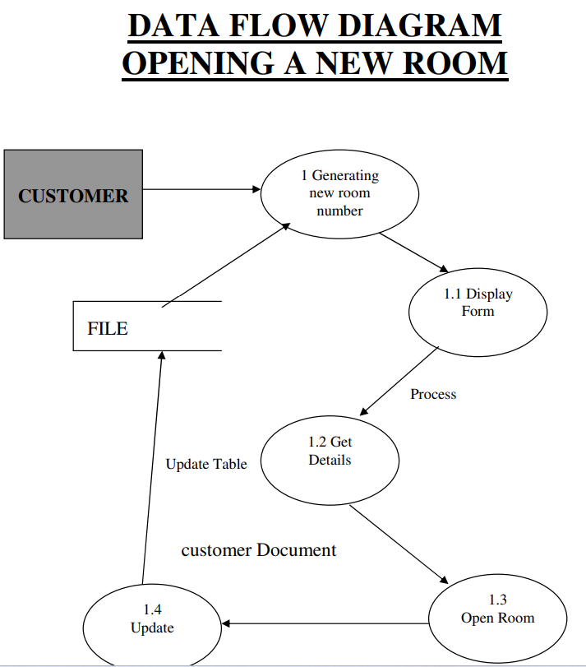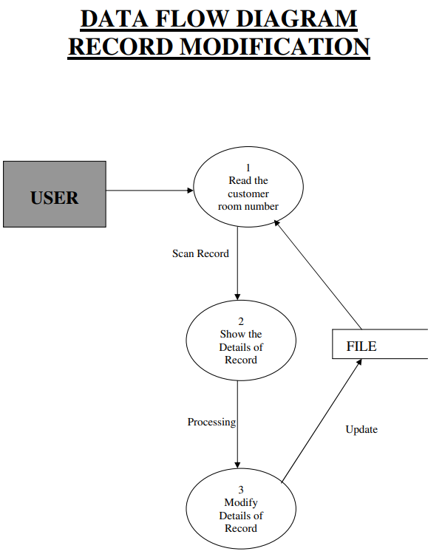

1. **Mathematical Model**

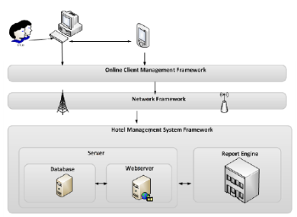

Figure 1:Architectural Framework For Hotel Management System

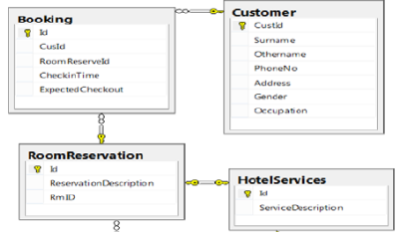

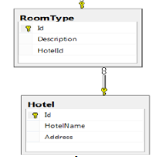

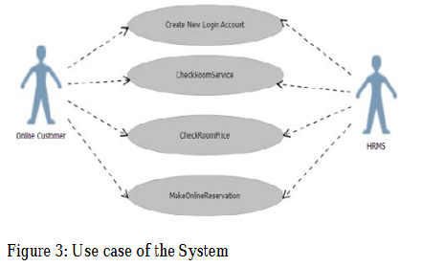

Figure 2: Database structure of the system

**Algorithm:**

1. Login To the System and Confirm the Admin access.

2. Add Customer Details to the customer Tab.

3. The Details of available rooms added by the hotel staff in the Details tab.

4. the available room will book by the customer as per choice through the room tab.

5. Billing details are also included in the Room tab.

6. To LOGOUT the system simply click on the logout Button.

1. **Desired Implications**

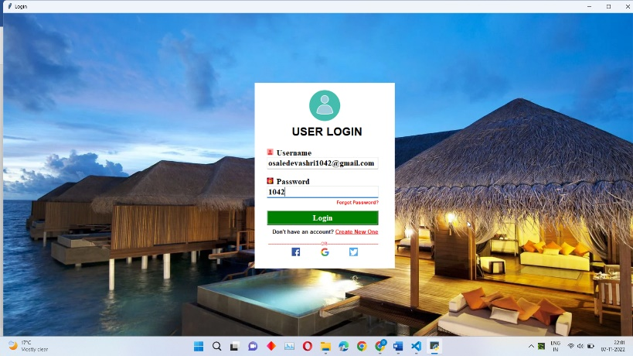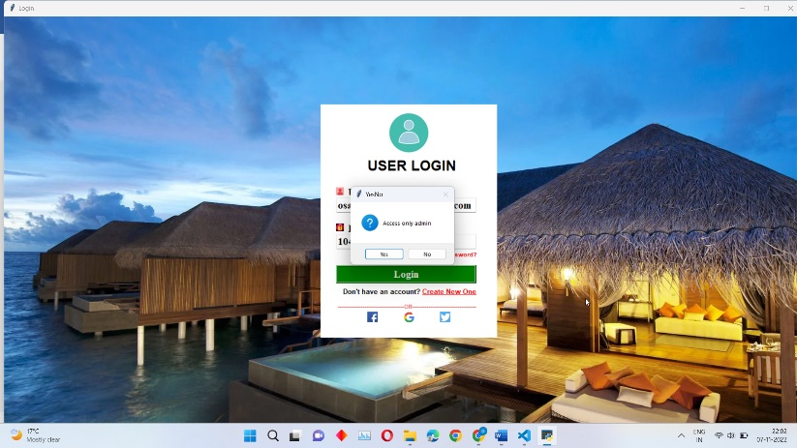Screenshot Of Hotel management system interface

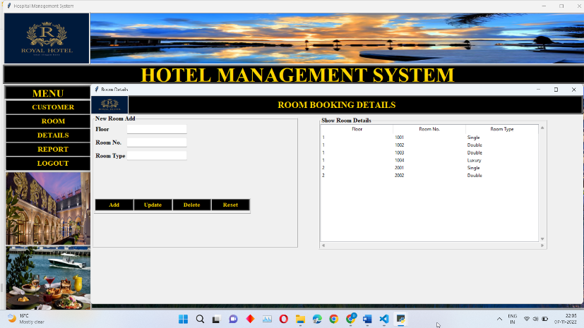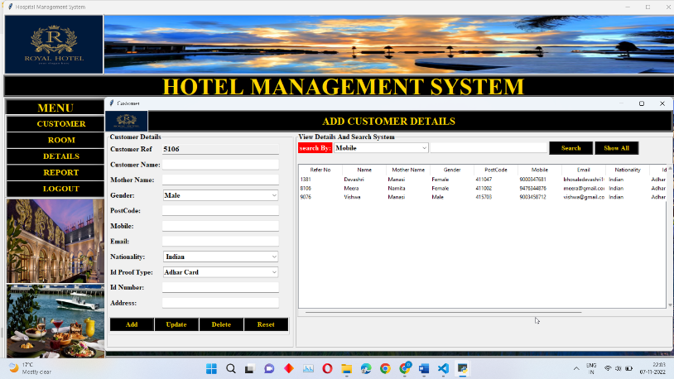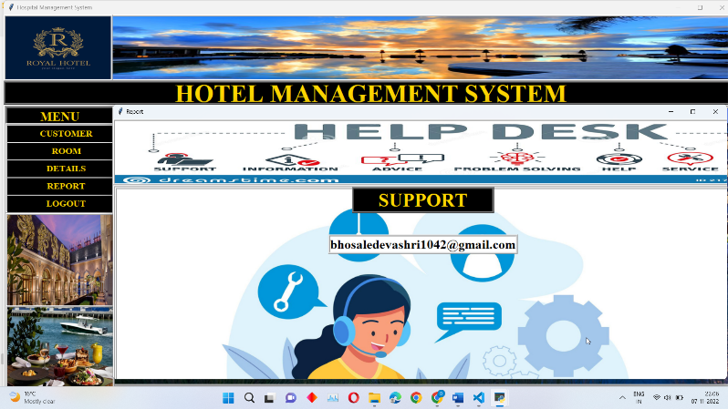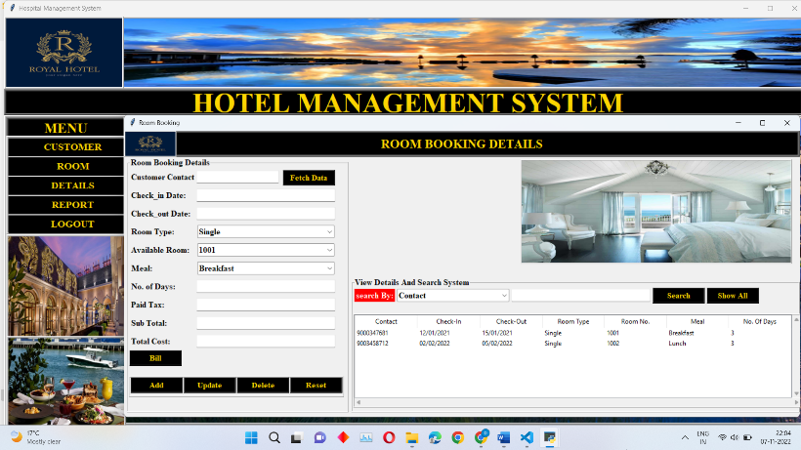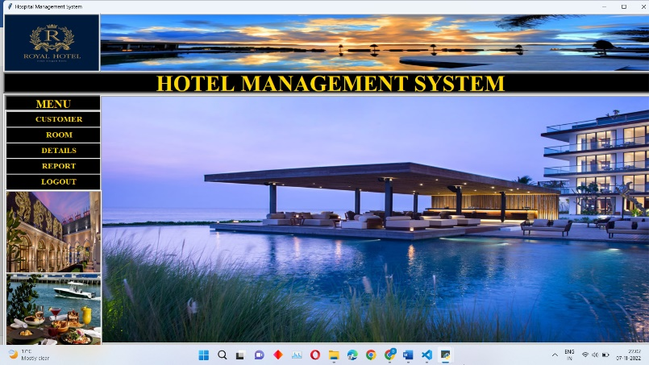

1. **References: (as per IEEE format)**

* S. Koolmanojwong, "Analysis and Design of B to C E-Marketplace for Tourism with UML " M.S. Thesis, Faculty of Science and Technology, Assumption
* University, Bangkok, Thailand 2000.
* M. J. O'Fallon and D.G. Rutherford.(2011).Hotel Management and Operations | CA College of Ayurveda.
* Available: http://www.ayurvedacollege.com/ amazon_store
* /item / 0470177144
* S. Koolmanojwong and P. Santiprabhob, "Intelligent Electronic Marketplace for Tourism."
* E. W. T. Ngai and F. K. T. Wat, "Design and development of a fuzzy expert system for hotel selection," Omega, vol. 31, pp. 275-286, 2003.
* G. Jingzhi, et al., "Alibaba International: Building a Global Electronic Marketplace," in e-Business Engineering, 2006. ICEBE '06. IEEE International Conference on, 2006, pp. 545-548.
* W. S. Gray and S. C. Liguori, Hotel and Motel Management and Operations, Fourth Edition ed.: Prentice
* Hall, 2002.
* W. J. Relihan Iii, "The yield-management approach to hotel-room pricing," The Cornell Hotel and Restaurant Administration Quarterly, vol. 30, pp. 40-45, 1989.
* M. S. Islam, et al., "An Automated Intelligent Hotel Management System," in 2009 Interdisciplinary Conference in Chemical, Mechanical and Materials
* Engineering (2009 ICCMME), Melbourne, Australia,
* 2009.
* Ogirima Sanni Omuya “Computerized Hotel Management”. Unpublished Higher National Diploma (HND) dissertation, Department of Computer Science, Kwara State Polytechnic,Ilorin, Nigeria.
* Landvogt, M. (2004) Online booking engines for small and medium-sizedenterprises as a tool for improved distribution and yield management in New Zealand’s tourism industry. In Smith, K. A. and Schott, C. (2004) eds. Proceedings of New Zealand Tourism and Hospitality Research Conference 2004. Wellington, 8-10 December. pp. 191-198. Available online at:33 http://www.vms.vuw.ac.nz /vuw/fca /vms/files/aa42.pdf (Accessed 21st July 2006).
* Law, R., J. Wong (2003) Successful factors for a travel web site: Perceptions of online purchasers in Hong Kong. Journal of Hospitality and Tourism Research 27(1), pp. 118-124.
* Law, R., K. Leung (2005) Online airfare reservation services: A study of Asian-based and North American-based travel websites. Information Technology
* and Tourism 5(1), pp. 25-33
* Schegg, R., T. Steiner, S. Frey, J. Murphy (2002) Benchmarks of website design and marketing by Swiss hotels. Information Technology and Tourism 5(2), pp. 73-89
* Ivanov, S (2002) Online hotel reservation systems. Proceedings of “Tourismin 21st Century” Conference, Sofia University, 29th November 2002, Sofia, Bulgaria, pp.
* 248-254(in Bulgarian).

**Coordinator Name Class Teacher: H.O.D**

**Prof. Vaishali Baviskar Prof. Radha Shirbhate Prof.Rachna Sable**